EENG-5560 Final Project Report

SUBMITTED BY

NARAYANA REDDY SANDRU – 11558422

VEERA VENKATA ABHINAV VYTLA - 11616686

Table of Contents

Specifications 3

Design 3

Block diagram 3

Design explanation: 6

Arithmetic handling: 15

Shift Operations: 15

Comparison operations: 16

Results 16

Generated RTL Schematic 16

Waveforms 20

Table/Calculations 28

# Specifications

|  |  |
| --- | --- |
| Requirement | Design Follows Requirement |
| Input data width: 4 bits | Yes |
| Homogeneous Computational Units (CUs) | Yes |
| Heterogeneous Interconnects | Yes |
| Interconnects with mirroring | Yes |
| Pass and No Op operation support | Yes |
| Support for all of the DFGs on the Super-architecture | Yes |

# Design

## Block diagram

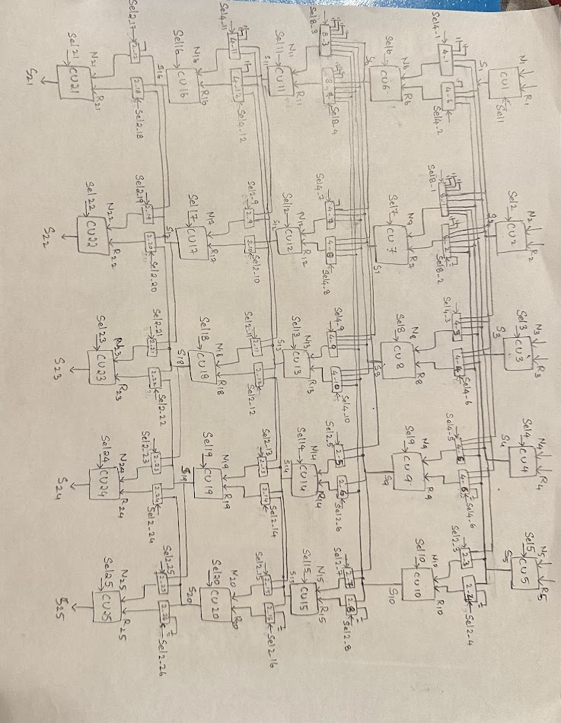

Figure -Block diagram of 5 X 5 Fabric

* The block diagram shows the 5 x 5 reconfigurable architecture fabric.(5 rows & 5 columns)
* The fabric consists a total of 25 CU’s (Computational Unit’s), 4 no’s of 8:1 mux’s,

12 no’s of 4:1 mux’s, and 24 no’s of 2:1 mux’s

* The data width for the CU is 4 bits wide.
* Each CU can perform 19 operations. These include Arithmetic, Shift and Comparison operations.
* Each of the mux’s used are operated based on mirroring concept.
* The CU’s in the fabric are operated based on the Data flow graphs given in the problem. And the operation of the fabric is left justified.
* There is no multi-level connectivity in the fabric.
* Pass Gates are used in the fabric to pass the output values from 1st row to 3rd /4th / 5th row CU’s. Two pass gates are used for this, namely Pass gate 1 & Pass gate 2.
* CU with Pass Gate 1 operation passes the output for Input 1.
* CU with Pass Gate 2 operation passes the output for Input 2.
* Depending on data flow graph’s given each CU does the operation specified to it.
* The rest of all CU’s are set to No Operation (NOOP), where these CU’s output is 0000 irrespective of inputs.
* We will get the final outputs from S21 and S22 depending on DFG’s.

**Overall Component**: 5 x 5 Fabric

* Overall ports:
  + Inputs:
    - N1, R1, N2, R2, N3, R3, N4, R4, N5, R5: 4 bits
    - Sel 1 - Sel 25: 5 bits (CU Sel’s)
  + Outputs:
    - S21, S22, S23, S24, S25: 4 bits
* Subcomponents:
  + **ALU**

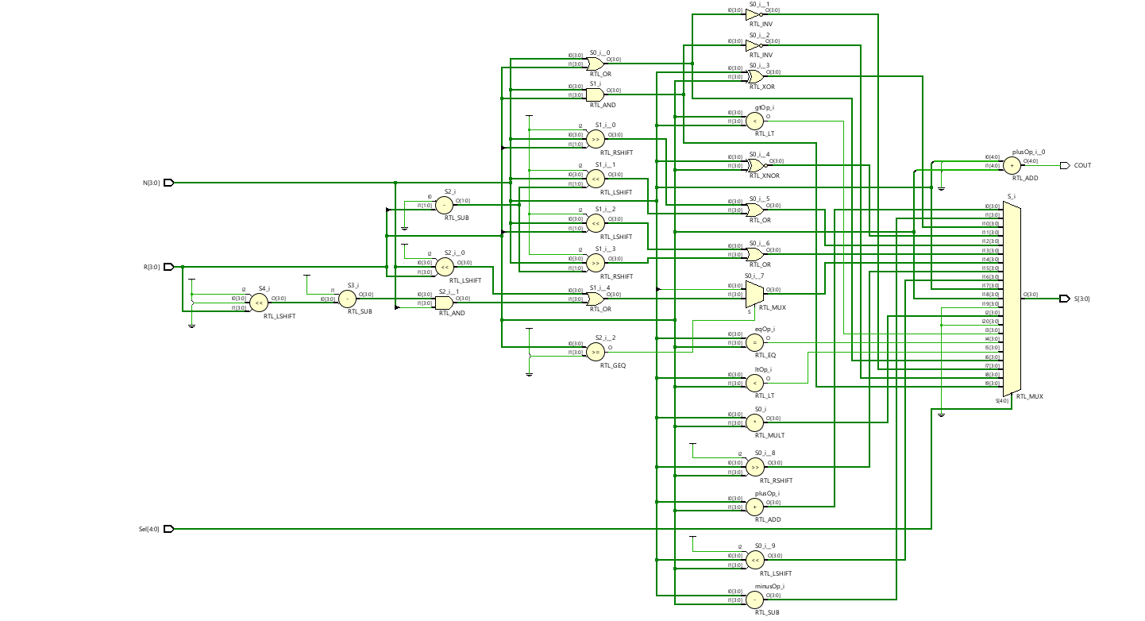

N, R: Input’s (4 bits)

S: Output (4 bits)

Sel: Selector (5 bit’s)

* + **8:1 Mux**

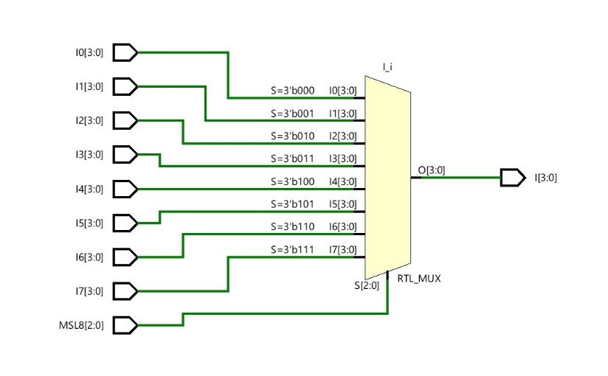

I0,I1,I2,I3,I4,I5,I6,I7 : Inputs(4 bit)  
MSL8 : Selector (3 bits)  
I : Output(4 bit)

* + **4:1 Mux**

J0,J1,J2,J3 : Inputs(4 bit)

MSL4 : Selector(2 bit)

J : Output(4bit)

* + **2:1 Mux**

K0, K1: Inputs (4 bit)

MSL2: Selector (1 bit)

K: Output (4 bit)

* Necessary intermediate signals:
  + S1, S2, S3, S4, S5, S6, S7, S8, S9, S10, S11, S12, S13, S14, S15, S16, S17, S18, S19, S20,

S21, S22, S23, S24, S25: outputs of CU’s given as input’s to 8:1,4:1,2:1 mux’s.

* + N6,R6,N7,R7,N8,R8,N9,R9,N10,R10,N11,R11,N12,R12,N13,R13,N14,R14,N15,R15,

N16,R16,N17,R17,N18,R18,N19,R19,N20,R20,N21,R21,N22,R22,N23,R23,N24,R24,

N25,R25 : Output’s from mux’s given as input’s to next row CU’s, 4 bits

Opcode table: (FOR CU’s)

|  |  |
| --- | --- |
| **OPCODE** | **OPERATION** |
| 00000 | ADDITION (+) |
| 00001 | SUBTRACTION (-) |
| 00010 | MULTIPLICATION (*) |
| 00011 | EQUAL TO (=) |
| 00100 | GREATER THAN (>) |
| 00101 | LESS THAN (<) |
| 00110 | OR |
| 00111 | NOR |
| 01000 | AND |
| 01001 | XOR |
| 01011 | XNOR |
| 01100 | ROR (rotate right) |
| 01101 | ROL (rotate left) |
| 01110 | ASL (arithmetic shift left) |
| 01111 | LSR (logical shift right) |
| 10000 | LSL (logical shift left) |
| 10001 | PASS GATE-1 |
| 10010 | PASS GATE-2 |
| 10011 | NO OPERATION |

## Design explanation:

* The design of the 5 x 5 fabric satisfies all the conditions that were given in the DFG’s.
* Two Input’s(4bit) are given to each and every CU presented in the fabric. Based on the DFG the operations are assigned to each CU depending on their Opcode(Sel line). And output(4 bit) is generated
* A total of 25 CU’s are included in this fabric.
* For the connectivity between the 1st row CU’s to the next row CU’s we used different mux’s(8:1/4:1/2:1) depending on the connectivity. i.e., output’s of 1st row CU’s are given as input’s to next row CU’s and so on up to 5 rows.
* For this handling we used two mux’s(which are mirrored to each other) for each CU inputs. We used mirroring concept to connect the mux’s. Basically the two mux’s combined gets us reachability. i.e., for 2:1 pair of mux’s it is -1 to +1 and for 4:1 pair of mux’s -2 to +2 and for 8:1 pair of mux’s it is -4 to +4
* We used 8:1 mux, because we have operated our CU’s in the fabric to be left justified. So in this case, if the 1st CU of 2nd row wants to get an input from 5th CU of 1st row we can easily reach with the help of mirrored 8:1 mux.
* Similarly 4:1 and 2:1 mux’s are used by considering the data flow that was specified in the DFG’s given and the type of CU connections that are specified in all DFG’s.
* **For DFG-1:** As given in the DFG the operations and connectivity for the CU’s are given accordingly. CU1 performs addition, CU2 performs multiplication, CU3-addition, CU4-subtraction, CU-5 multiplication, for the given set of inputs for each CU.
* Now the outputs from the first row CU’s i.e., S1,S2,S3,S4,S5 are given as inputs to the next row CU’s by using mux’s. The output’s from row 1 CU’s are first given as inputs to mux’s present below and the output’s from the mux’s based on the sel line of the mux(MSL) is given as input to next row CU.
* For **CU6(SUB)** inputs N6,R6 are taken from outputs of CU1 & CU3. For this Mux’s 4_1, 4_2 are used. For mux 4_1, pins J0,J1 are grounded. And J2 is connected to S1& J3 is connected to S2. And in mux 4_2 J0 pin is grounded and pins J1,J2,J3 are connected to S1,S2,S3 respectively. Mux 4_1 gives output from pin J2 by setting MSL4_1 as “10”. And mux 4_2 gives output from pin J3 by setting MSL4_2 as “11”.
* For **CU7(ADD)** inputs N7,R7 are taken from outputs of CU3 & CU5 . For this Mux’s 8_1, 8_2 are used. For mux 8_1, pins I0,I1,I2 are grounded and pins I3,I4,I5,I6,I7 are connected to outputs S1,S2,S3,S4,S5 respectively. In mux 8_2 pins I0,I1,I7 are grounded and I2,I3,I4,I5,I6 are connected to outputs S1,S2,S3,S4,S5 respectively. Mux 8_1 gives output from pin I5 by setting MSL8_1 as “101” and for mux 8_2 from pin I6 by setting MSL8_2 as “110”.
* For **CU8(SUB)** inputs N8,R8 are taken from outputs of CU2 & CU4 . For this Mux’s 4_3, 4_4 are used. For mux 4_3, pins J0,J1,J2,J3 are connected to outputs S1,S2,S3,S4 respectively. In mux 4_4 pins J0,J1,J2,J3 are connected to outputs S2,S3,S4,S5 respectively. Mux 4_3 gives output from pin J1 by setting MSL4_3 as “01” and for mux 4_4 from pin J2 by setting MSL4_4 as “10”.
* For **CU9(PG 2)** inputs N9,R9 are taken from outputs of CU2 & CU5 . For this Mux’s 4_5, 4_6 are used. For mux 4_5, pins J0,J1,J2,J3 are connected to outputs S2,S3,S4,S5 respectively. In mux 4_6 pins J0,J1,J2 are connected to outputs S3,S4,S5 respectively, pin J3 is grounded. Mux 4_5 gives output from pin J0 by setting MSL4_5 as “00” and for mux 4_6 from pin J2 by setting MSL4_6 as “10”.
* For **CU10(NOOP)** inputs N10,R10 are taken from outputs of CU5 & CU5 . For this Mux’s 2_3, 2_4 are used. For mux 2_3, pins K0,K1 are connected to outputs S4,S5 respectively. In mux 2_4 pin K0 is connected to output S5, pin K1 is grounded. Mux 2_3 gives output from pin K1by setting MSL2_3 as “1” and for mux 2_4 from pin K0 by setting MSL2_4 as “0”.
* Now the output’s from CU6, CU7, CU8, CU9, CU10 are S6, S7, S8, S9, S10 respectively. These outputs are given as inputs to third row CU’s, CU11-CU15 by using mux’s.
* For **CU11(OR)** inputs N11,R11 are taken from outputs of CU6 & CU8 . For this Mux’s 8_3, 8_4 are used. For mux 8_3, pins I0,I1,I2,I3 are grounded and pins I4,I5,I6,I7 are connected to outputs S6,S7,S8,S9 respectively. In mux 8_3 pins I0,I1,I2 are grounded and pins I3,I4,I5,I6,I7 are connected to outputs S6,S7,S8,S9,S10 respectively. Mux 8_3 gives output from pin I4 by setting MSL8_3 as “100” and for mux 8_4 from pin I5 by setting MSL8_4 as “101”.
* For **CU12(AND)** inputs N12,R12 are taken from outputs of CU7 & CU8 . For this Mux’s 4_7, 4_8 are used. For mux 4_7, pins J1,J2,J3 are connected to outputs S6,S7,S8 respectively, pin J0 is grounded. In mux 4_8 pins J0,J1,J2,J3 are connected to outputs S6,S7,S8,S9 respectively. Mux 4_7 gives output from pin J2 by setting MSL4_7 as “10” and for mux 4_8 from pin J2 by setting MSL4_8 as “10”.
* For **CU13(NAND)** inputs N13,R13 are taken from outputs of CU6 & CU9 . For this Mux’s 4_9, 4_10 are used. For mux 4_9, pins J0,J1,J2,J3 are connected to outputs S6,S7,S8,S9 respectively. In mux 4_10 pins J0,J1,J2,J3 are connected to outputs S7,S8,S9,S10 respectively. Mux 4_9 gives output from pin J0 by setting MSL4_9 as “00” and for mux 4_10 from pin J2 by setting MSL4_10 as “10”.
* For **CU14(NOOP)** inputs N14,R14 are taken from outputs of CU8 & CU9 . For this Mux’s 2_5, 2_6 are used. For mux 2_5, pins K0,K1 are connected to outputs S8,S9 respectively. In mux 2_6 pin K0,K1 are connected to outputs S9,S10. Mux 2_5 gives output from pin K0 by setting MSL2_5 as “0” and for mux 2_4 from pin K0 by setting MSL2_6 as “0”.
* For **CU15(NOOP)** inputs N15,R15 are taken from outputs of CU9 & CU10 . For this Mux’s 2_7, 2_8 are used. For mux 2_7, pins K0,K1 are connected to outputs S9,S10 respectively. In mux 2_8 pin K0 is connected to output S10, K1 is grounded. Mux 2_7 gives output from pin K0 by setting MSL2_7 as “0” and for mux 2_8 from pin K0 by setting MSL2_8 as “0”.
* Now the output’s from CU11, CU12, CU13, CU14, CU15 are S11, S12, S13, S14, S15 respectively. These outputs are given as inputs to fourth row CU’s, CU16-CU20 by using mux’s.
* For **CU16(XOR)** inputs N16,R16 are taken from outputs of CU11 & CU12 . For this Mux’s 4_11, 4_12 are used. For mux 4_11, pins J0,J1 are grounded and pins J2,J3 are connected to outputs S11,S12 respectively. In mux 4_12 pin J0 is grounded and pins J1,J2,J3 are connected to outputs S11,S12,S13 respectively. Mux 4_ 11 gives output from pin J2 by setting MSL4_11 as “10” and for mux 4_12 from pin J2 by setting MSL4_12 as “10”.
* For **CU17(NOR)** inputs N17,R17 are taken from outputs of CU12 & CU13 . For this Mux’s 2_9, 2_10 are used. For mux 2_9, pins K0,K1 are connected to outputs S11,S12 respectively. In mux 2_10 pin K0,K1 are connected to outputs S12,S13. Mux 2_9 gives output from pin K1 by setting MSL2_9 as “1” and for mux 2_10 from pin K1 by setting MSL2_10 as “1”.
* For **CU18(NOOP)** inputs N18,R18 are taken from outputs of CU12 & CU14 . For this Mux’s 2_11, 2_12 are used. For mux 2_11, pins K0,K1 are connected to outputs S12,S13 respectively. In mux 2_12 pin K0,K1 are connected to outputs S13,S14. Mux 2_11 gives output from pin K0 by setting MSL2_11 as “0” and for mux 2_12 from pin K1 by setting MSL2_12 as “1” .
* For **CU19(NOOP)** inputs N19,R19 are taken from outputs of CU13 & CU14 . For this Mux’s 2_13, 2_14 are used. For mux 2_13, pins K0,K1 are connected to outputs S13,S14 respectively. In mux 2_14 pin K0,K1 are connected to outputs S14,S15. Mux 2_13 gives output from pin K0 by setting MSL2_13 as “0” and for mux 2_14 from pin K0 by setting MSL2_14 as “0”.
* For **CU20(NOOP)** inputs N20,R20 are taken from outputs of CU14 & CU15 . For this Mux’s 2_15, 2_16 are used. For mux 2_15, pins K0,K1 are connected to outputs S14,S15 respectively. In mux 2_16 pin K0 is connected to output S15, and pin K1 is grounded. Mux 2_15 gives output from pin K0 by setting MSL2_15 as “0” and for mux 2_16 from pin K0 by setting MSL2_16 as “0”.
* The output’s from CU16, CU17, CU18, CU19, CU20 are S16, S17, S18, S19, S20 respectively. These outputs are given as inputs to fifth row CU’s, CU21-CU25 by using mux’s.
* For **CU21(PG 1)** inputs N21,R21 are taken from outputs of CU16 & CU17 . For this Mux’s 2_17, 2_18 are used. For mux 2_17, pin K0 is grounded and pin K1 is connected to output S16. In mux 2_18 pins K0,K1 are connected to S16,S17 respectively. Mux 2_17 gives output from pin K1 by setting MSL2_17 as “1” and for mux 2_18 from pin K1 by setting MSL2_18 as “1”.
* For **CU22(PG 2)** inputs N22,R22 are taken from outputs of CU16 & CU17 . For this Mux’s 2_19, 2_20 are used. For mux 2_19, pins K0,K1 are connected to outputs S16,S17 respectively. In mux 2_20 pin K0,K1 are connected to outputs S17,S18. Mux 2_19 gives output from pin K0 by setting MSL2_19 as “0” and for mux 2_20 from pin K0 by setting MSL2_20 as “0”.
* For **CU23(NOOP)** inputs N23,R23 are taken from outputs of CU17 & CU19 . For this Mux’s 2_21, 2_22 are used. For mux 2_21, pins K0,K1 are connected to outputs S17,S18 respectively. In mux 2_22 pin K,K1 are connected to outputs S18,S19. Mux 2_22 gives output from pin K0 by setting MSL2_21 as “0” and for mux 2_22 from pin K1 by setting MSL2_10 as “1”.
* For **CU24(NOOP)** inputs N24,R24 are taken from outputs of CU18 & CU19 . For this Mux’s 2_23, 2_24 are used. For mux 2_23, pins K0,K1 are connected to outputs S18,S19 respectively. In mux 2_24 pin K0,K1 are connected to outputs S19,S20. Mux 2_23 gives output from pin K0 by setting MSL2_23 as “0” and for mux 2_24 from pin K0 by setting MSL2_24 as “0”.
* For **CU25(NOOP)** inputs N25,R25 are taken from outputs of CU19 & CU20 . For this Mux’s 2_25, 2_26 are used. For mux 2_25, pins K0,K1 are connected to outputs S19,S20 respectively. In mux 2_26 pin K0 is connected to output S20and K1 is grounded. Mux 2_25 gives output from pin K0 by setting MSL2_25 as “0” and for mux 2_26 from pin K0 by setting MSL2_26 as “0”.
* The output’s from CU21, CU22, CU23, CU24, CU25 are S21, S22, S23, S24, S25 respectively.
* For the DFG-1 we take outputs from CU21,CU22. i.e., S21&S22.
* **For DFG-2:** As given in the DFG the operations and connectivity for the CU’s are given accordingly. CU1 performs subtraction, CU2 performs multiplication, CU3-NOOP, CU4-addition, CU-5 multiplication, for the given set of inputs for each CU.
* Now the outputs from the first row CU’s i.e., S1,S2,S3,S4,S5 are given as inputs to the next row CU’s by using mux’s. The output’s from row 1 CU’s are first given as inputs to mux’s present below and the output’s from the mux’s based on the sel line of the mux(MSL) is given as input to next row CU.
* For **CU6(PG 1)** inputs N6,R6 are taken from outputs of CU1 & CU3. For this Mux’s 4_1, 4_2 are used. For mux 4_1, pins J0,J1 are grounded. And J2 is connected to S1& J3 is connected to S2. And in mux 4_2 J0 pin is grounded and pins J1,J2,J3 are connected to S1,S2,S3 respectively. Mux 4_1 gives output from pin J2 by setting MSL4_1 as “10”. And mux 4_2 gives output from pin J3 by setting MSL4_2 as “11”.
* For **CU7(ADD)** inputs N7,R7 are taken from outputs of CU1 & CU4 . For this Mux’s 8_1, 8_2 are used. For mux 8_1, pins I0,I1,I2 are grounded and pins I3,I4,I5,I6,I7 are connected to outputs S1,S2,S3,S4,S5 respectively. In mux 8_2 pins I0,I1,I7 are grounded and I2,I3,I4,I5,I6 are connected to outputs S1,S2,S3,S4,S5 respectively. Mux 8_1 gives output from pin I3 by setting MSL8_1 as “011” and for mux 8_2 from pin I5 by setting MSL8_2 as “101”.
* For **CU8(SUB)** inputs N8,R8 are taken from outputs of CU1 & CU5 . For this Mux’s 4_3, 4_4 are used. For mux 4_3, pins J0,J1,J2,J3 are connected to outputs S1,S2,S3,S4 respectively. In mux 4_4 pins J0,J1,J2,J3 are connected to outputs S2,S3,S4,S5 respectively. Mux 4_3 gives output from pin J0 by setting MSL4_3 as “00” and for mux 4_4 from pin J3 by setting MSL4_4 as “11”.
* For **CU9(ADD)** inputs N9,R9 are taken from outputs of CU2 & CU5 . For this Mux’s 4_5, 4_6 are used. For mux 4_5, pins J0,J1,J2,J3 are connected to outputs S2,S3,S4,S5 respectively. In mux 4_6 pins J0,J1,J2 are connected to outputs S3,S4,S5 respectively, pin J3 is grounded. Mux 4_5 gives output from pin J0 by setting MSL4_5 as “00” and for mux 4_6 from pin J2 by setting MSL4_6 as “10”.
* For **CU10(PG 1)** inputs N10,R10 are taken from outputs of CU4 & CU5 . For this Mux’s 2_3, 2_4 are used. For mux 2_3, pins K0,K1 are connected to outputs S4,S5 respectively. In mux 2_4 pin K0 is connected to output S5, pin K1 is grounded. Mux 2_3 gives output from pin K0 by setting MSL2_3 as “0” and for mux 2_4 from pin K0 by setting MSL2_4 as “0”.
* Now the output’s from CU6, CU7, CU8, CU9, CU10 are S6, S7, S8, S9, S10 respectively. These outputs are given as inputs to third row CU’s, CU11-CU15 by using mux’s.
* For **CU11(ROR)** inputs N11,R11 are taken from outputs of CU6 & CU9 . For this Mux’s 8_3, 8_4 are used. For mux 8_3, pins I0,I1,I2,I3 are grounded and pins I4,I5,I6,I7 are connected to outputs S6,S7,S8,S9 respectively. In mux 8_3 pins I0,I1,I2 are grounded and pins I3,I4,I5,I6,I7 are connected to outputs S6,S7,S8,S9,S10 respectively. Mux 8_3 gives output from pin I4 by setting MSL8_3 as “100” and for mux 8_4 from pin I6 by setting MSL8_4 as “110”.
* For **CU12(PG 2)** inputs N12,R12 are taken from outputs of CU7 & CU8 . For this Mux’s 4_7, 4_8 are used. For mux 4_7, pins J1,J2,J3 are connected to outputs S6,S7,S8 respectively, pin J0 is grounded. In mux 4_8 pins J0,J1,J2,J3 are connected to outputs S6,S7,S8,S9 respectively. Mux 4_7 gives output from pin J2 by setting MSL4_7 as “10” and for mux 4_8 from pin J2 by setting MSL4_8 as “10”.
* For **CU13(LSL)** inputs N13,R13 are taken from outputs of CU7 & CU10 . For this Mux’s 4_9, 4_10 are used. For mux 4_9, pins J0,J1,J2,J3 are connected to outputs S6,S7,S8,S9 respectively. In mux 4_10 pins J0,J1,J2,J3 are connected to outputs S7,S8,S9,S10 respectively. Mux 4_9 gives output from pin J1 by setting MSL4_9 as “01” and for mux 4_10 from pin J3 by setting MSL4_10 as “11”.
* For **CU14(NOOP)** inputs N14,R14 are taken from outputs of CU8 & CU9 . For this Mux’s 2_5, 2_6 are used. For mux 2_5, pins K0,K1 are connected to outputs S8,S9 respectively. In mux 2_6 pin K0,K1 are connected to outputs S9,S10. Mux 2_5 gives output from pin K0 by setting MSL2_5 as “0” and for mux 2_4 from pin K0 by setting MSL2_6 as “0”.
* For **CU15(NOOP)** inputs N15,R15 are taken from outputs of CU9 & CU10 . For this Mux’s 2_7, 2_8 are used. For mux 2_7, pins K0,K1 are connected to outputs S9,S10 respectively. In mux 2_8 pin K0 is connected to output S10, K1 is grounded. Mux 2_7 gives output from pin K0 by setting MSL2_7 as “0” and for mux 2_8 from pin K0 by setting MSL2_8 as “0”.
* Now the output’s from CU11, CU12, CU13, CU14, CU15 are S11, S12, S13, S14, S15 respectively. These outputs are given as inputs to fourth row CU’s, CU16-CU20 by using mux’s.
* For **CU16(GREATER THAN)** inputs N16,R16 are taken from outputs of CU11 & CU13 . For this Mux’s 4_11, 4_12 are used. For mux 4_11, pins J0,J1 are grounded and pins J2,J3 are connected to outputs S11,S12 respectively. In mux 4_12 pin J0 is grounded and pins J1,J2,J3 are connected to outputs S11,S12,S13 respectively. Mux 4_ 11 gives output from pin J2 by setting MSL4_11 as “10” and for mux 4_12 from pin J3 by setting MSL4_12 as “11”.
* For **CU17(EQUAL TO)** inputs N17,R17 are taken from outputs of CU11 & CU12 . For this Mux’s 2_9, 2_10 are used. For mux 2_9, pins K0,K1 are connected to outputs S11,S12 respectively. In mux 2_10 pin K0,K1 are connected to outputs S12,S13. Mux 2_9 gives output from pin K0 by setting MSL2_9 as “0” and for mux 2_10 from pin K0 by setting MSL2_10 as “0”.
* For **CU18(NOOP)** inputs N18,R18 are taken from outputs of CU12 & CU14 . For this Mux’s 2_11, 2_12 are used. For mux 2_11, pins K0,K1 are connected to outputs S12,S13 respectively. In mux 2_12 pin K0,K1 are connected to outputs S13,S14. Mux 2_11 gives output from pin K0 by setting MSL2_11 as “0” and for mux 2_12 from pin K1 by setting MSL2_12 as “1” .
* For **CU19(NOOP)** inputs N19,R19 are taken from outputs of CU13 & CU14 . For this Mux’s 2_13, 2_14 are used. For mux 2_13, pins K0,K1 are connected to outputs S13,S14 respectively. In mux 2_14 pin K0,K1 are connected to outputs S14,S15. Mux 2_13 gives output from pin K0 by setting MSL2_13 as “0” and for mux 2_14 from pin K0 by setting MSL2_14 as “0”.
* For **CU20(NOOP)** inputs N20,R20 are taken from outputs of CU14 & CU15 . For this Mux’s 2_15, 2_16 are used. For mux 2_15, pins K0,K1 are connected to outputs S14,S15 respectively. In mux 2_16 pin K0 is connected to output S15, and pin K1 is grounded. Mux 2_15 gives output from pin K0 by setting MSL2_15 as “0” and for mux 2_16 from pin K0 by setting MSL2_16 as “0”.
* The output’s from CU16, CU17, CU18, CU19, CU20 are S16, S17, S18, S19, S20 respectively. These outputs are given as inputs to fifth row CU’s, CU21-CU25 by using mux’s.
* For **CU21(PG 1)** inputs N21,R21 are taken from outputs of CU16 & CU17 . For this Mux’s 2_17, 2_18 are used. For mux 2_17, pin K0 is grounded and pin K1 is connected to output S16. In mux 2_18 pins K0,K1 are connected to S16,S17 respectively. Mux 2_17 gives output from pin K1 by setting MSL2_17 as “1” and for mux 2_18 from pin K1 by setting MSL2_18 as “1”.
* For **CU22(PG 2)** inputs N22,R22 are taken from outputs of CU16 & CU17 . For this Mux’s 2_19, 2_20 are used. For mux 2_19, pins K0,K1 are connected to outputs S16,S17 respectively. In mux 2_20 pin K0,K1 are connected to outputs S17,S18. Mux 2_19 gives output from pin K0 by setting MSL2_19 as “0” and for mux 2_20 from pin K0 by setting MSL2_20 as “0”.
* For **CU23(NOOP)** inputs N23,R23 are taken from outputs of CU17 & CU19 . For this Mux’s 2_21, 2_22 are used. For mux 2_21, pins K0,K1 are connected to outputs S17,S18 respectively. In mux 2_22 pin K,K1 are connected to outputs S18,S19. Mux 2_22 gives output from pin K0 by setting MSL2_21 as “0” and for mux 2_22 from pin K1 by setting MSL2_10 as “1”.
* For **CU24(NOOP)** inputs N24,R24 are taken from outputs of CU18 & CU19 . For this Mux’s 2_23, 2_24 are used. For mux 2_23, pins K0,K1 are connected to outputs S18,S19 respectively. In mux 2_24 pin K0,K1 are connected to outputs S19,S20. Mux 2_23 gives output from pin K0 by setting MSL2_23 as “0” and for mux 2_24 from pin K0 by setting MSL2_24 as “0”.
* For **CU25(NOOP)** inputs N25,R25 are taken from outputs of CU19 & CU20 . For this Mux’s 2_25, 2_26 are used. For mux 2_25, pins K0,K1 are connected to outputs S19,S20 respectively. In mux 2_26 pin K0 is connected to output S20and K1 is grounded. Mux 2_25 gives output from pin K0 by setting MSL2_25 as “0” and for mux 2_26 from pin K0 by setting MSL2_26 as “0”.
* The output’s from CU21, CU22, CU23, CU24, CU25 are S21, S22, S23, S24, S25 respectively.
* For the DFG-2 we take outputs from CU21,CU22. i.e., S21&S22.
* **For DFG-3:** As given in the DFG the operations and connectivity for the CU’s are given accordingly. CU1 performs addition, CU2 performs subtraction, CU3-multiplication, CU4-multiplication, CU-5 NOOP, for the given set of inputs for each CU.
* Now the outputs from the first row CU’s i.e., S1,S2,S3,S4,S5 are given as inputs to the next row CU’s by using mux’s. The output’s from row 1 CU’s are first given as inputs to mux’s present below and the output’s from the mux’s based on the sel line of the mux(MSL) is given as input to next row CU.
* For **CU6(SUB)** inputs N6,R6 are taken from outputs of CU1 & CU2. For this Mux’s 4_1, 4_2 are used. For mux 4_1, pins J0,J1 are grounded. And J2 is connected to S1& J3 is connected to S2. And in mux 4_2 J0 pin is grounded and pins J1,J2,J3 are connected to S1,S2,S3 respectively. Mux 4_1 gives output from pin J2 by setting MSL4_1 as “10”. And mux 4_2 gives output from pin J2 by setting MSL4_2 as “10”.
* For **CU7(PG 2)** inputs N7,R7 are taken from outputs of CU1 & CU3 . For this Mux’s 8_1, 8_2 are used. For mux 8_1, pins I0,I1,I2 are grounded and pins I3,I4,I5,I6,I7 are connected to outputs S1,S2,S3,S4,S5 respectively. In mux 8_2 pins I0,I1,I7 are grounded and I2,I3,I4,I5,I6 are connected to outputs S1,S2,S3,S4,S5 respectively. Mux 8_1 gives output from pin I3 by setting MSL8_1 as “011” and for mux 8_2 from pin I4 by setting MSL8_2 as “100”.
* For **CU8(ADD)** inputs N8,R8 are taken from outputs of CU2 & CU4 . For this Mux’s 4_3, 4_4 are used. For mux 4_3, pins J0,J1,J2,J3 are connected to outputs S1,S2,S3,S4 respectively. In mux 4_4 pins J0,J1,J2,J3 are connected to outputs S2,S3,S4,S5 respectively. Mux 4_3 gives output from pin J1 by setting MSL4_3 as “01” and for mux 4_4 from pin J2 by setting MSL4_4 as “10”.
* For **CU9(SUB)** inputs N9,R9 are taken from outputs of CU2 & CU4 . For this Mux’s 4_5, 4_6 are used. For mux 4_5, pins J0,J1,J2,J3 are connected to outputs S2,S3,S4,S5 respectively. In mux 4_6 pins J0,J1,J2 are connected to outputs S3,S4,S5 respectively, pin J3 is grounded. Mux 4_5 gives output from pin J0 by setting MSL4_5 as “00” and for mux 4_6 from pin J1 by setting MSL4_6 as “01”.
* For **CU10(NOOP)** inputs N10,R10 are taken from outputs of CU5 & CU5 . For this Mux’s 2_3, 2_4 are used. For mux 2_3, pins K0,K1 are connected to outputs S4,S5 respectively. In mux 2_4 pin K0 is connected to output S5, pin K1 is grounded. Mux 2_3 gives output from pin K1by setting MSL2_3 as “1” and for mux 2_4 from pin K0 by setting MSL2_4 as “0”.
* Now the output’s from CU6, CU7, CU8, CU9, CU10 are S6, S7, S8, S9, S10 respectively. These outputs are given as inputs to third row CU’s, CU11-CU15 by using mux’s.
* For **CU11(NOR)** inputs N11,R11 are taken from outputs of CU6 & CU7 . For this Mux’s 8_3, 8_4 are used. For mux 8_3, pins I0,I1,I2,I3 are grounded and pins I4,I5,I6,I7 are connected to outputs S6,S7,S8,S9 respectively. In mux 8_3 pins I0,I1,I2 are grounded and pins I3,I4,I5,I6,I7 are connected to outputs S6,S7,S8,S9,S10 respectively. Mux 8_3 gives output from pin I4 by setting MSL8_3 as “100” and for mux 8_4 from pin I4 by setting MSL8_4 as “100”.
* For **CU12(NAND)** inputs N12,R12 are taken from outputs of CU8 & CU9 . For this Mux’s 4_7, 4_8 are used. For mux 4_7, pins J1,J2,J3 are connected to outputs S6,S7,S8 respectively, pin J0 is grounded. In mux 4_8 pins J0,J1,J2,J3 are connected to outputs S6,S7,S8,S9 respectively. Mux 4_7 gives output from pin J3 by setting MSL4_7 as “11” and for mux 4_8 from pin J3 by setting MSL4_8 as “11”.
* For **CU13(NOOP)** inputs N13,R13 are taken from outputs of CU8 & CU9 . For this Mux’s 4_9, 4_10 are used. For mux 4_9, pins J0,J1,J2,J3 are connected to outputs S6,S7,S8,S9 respectively. In mux 4_10 pins J0,J1,J2,J3 are connected to outputs S7,S8,S9,S10 respectively. Mux 4_9 gives output from pin J2 by setting MSL4_9 as “10” and for mux 4_10 from pin J2 by setting MSL4_10 as “10”.
* For **CU14(NOOP)** inputs N14,R14 are taken from outputs of CU8 & CU9 . For this Mux’s 2_5, 2_6 are used. For mux 2_5, pins K0,K1 are connected to outputs S8,S9 respectively. In mux 2_6 pin K0,K1 are connected to outputs S9,S10. Mux 2_5 gives output from pin K0 by setting MSL2_5 as “0” and for mux 2_4 from pin K0 by setting MSL2_6 as “0”.
* For **CU15(NOOP)** inputs N15,R15 are taken from outputs of CU9 & CU10 . For this Mux’s 2_7, 2_8 are used. For mux 2_7, pins K0,K1 are connected to outputs S9,S10 respectively. In mux 2_8 pin K0 is connected to output S10, K1 is grounded. Mux 2_7 gives output from pin K0 by setting MSL2_7 as “0” and for mux 2_8 from pin K0 by setting MSL2_8 as “0”.
* Now the output’s from CU11, CU12, CU13, CU14, CU15 are S11, S12, S13, S14, S15 respectively. These outputs are given as inputs to fourth row CU’s, CU16-CU20 by using mux’s.
* For **CU16(PG 1)** inputs N16,R16 are taken from outputs of CU11 & CU12 . For this Mux’s 4_11, 4_12 are used. For mux 4_11, pins J0,J1 are grounded and pins J2,J3 are connected to outputs S11,S12 respectively. In mux 4_12 pin J0 is grounded and pins J1,J2,J3 are connected to outputs S11,S12,S13 respectively. Mux 4_ 11 gives output from pin J2 by setting MSL4_11 as “10” and for mux 4_12 from pin J2 by setting MSL4_12 as “10”.
* For **CU17(PG 2)** inputs N17,R17 are taken from outputs of CU11 & CU12 . For this Mux’s 2_9, 2_10 are used. For mux 2_9, pins K0,K1 are connected to outputs S11,S12 respectively. In mux 2_10 pin K0,K1 are connected to outputs S12,S13. Mux 2_9 gives output from pin K0 by setting MSL2_9 as “0” and for mux 2_10 from pin K0 by setting MSL2_10 as “0”.
* For **CU18(NOOP)** inputs N18,R18 are taken from outputs of CU12 & CU14 . For this Mux’s 2_11, 2_12 are used. For mux 2_11, pins K0,K1 are connected to outputs S12,S13 respectively. In mux 2_12 pin K0,K1 are connected to outputs S13,S14. Mux 2_11 gives output from pin K0 by setting MSL2_11 as “0” and for mux 2_12 from pin K1 by setting MSL2_12 as “1” .
* For **CU19(NOOP)** inputs N19,R19 are taken from outputs of CU13 & CU14 . For this Mux’s 2_13, 2_14 are used. For mux 2_13, pins K0,K1 are connected to outputs S13,S14 respectively. In mux 2_14 pin K0,K1 are connected to outputs S14,S15. Mux 2_13 gives output from pin K0 by setting MSL2_13 as “0” and for mux 2_14 from pin K0 by setting MSL2_14 as “0”.
* For **CU20(NOOP)** inputs N20,R20 are taken from outputs of CU14 & CU15 . For this Mux’s 2_15, 2_16 are used. For mux 2_15, pins K0,K1 are connected to outputs S14,S15 respectively. In mux 2_16 pin K0 is connected to output S15, and pin K1 is grounded. Mux 2_15 gives output from pin K0 by setting MSL2_15 as “0” and for mux 2_16 from pin K0 by setting MSL2_16 as “0”.
* The output’s from CU16, CU17, CU18, CU19, CU20 are S16, S17, S18, S19, S20 respectively. These outputs are given as inputs to fifth row CU’s, CU21-CU25 by using mux’s.
* For **CU21(PG 1)** inputs N21,R21 are taken from outputs of CU16 & CU17 . For this Mux’s 2_17, 2_18 are used. For mux 2_17, pin K0 is grounded and pin K1 is connected to output S16. In mux 2_18 pins K0,K1 are connected to S16,S17 respectively. Mux 2_17 gives output from pin K1 by setting MSL2_17 as “1” and for mux 2_18 from pin K1 by setting MSL2_18 as “1”.
* For **CU22(PG 2)** inputs N22,R22 are taken from outputs of CU16 & CU17 . For this Mux’s 2_19, 2_20 are used. For mux 2_19, pins K0,K1 are connected to outputs S16,S17 respectively. In mux 2_20 pin K0,K1 are connected to outputs S17,S18. Mux 2_19 gives output from pin K0 by setting MSL2_19 as “0” and for mux 2_20 from pin K0 by setting MSL2_20 as “0”.
* For **CU23(NOOP)** inputs N23,R23 are taken from outputs of CU17 & CU19 . For this Mux’s 2_21, 2_22 are used. For mux 2_21, pins K0,K1 are connected to outputs S17,S18 respectively. In mux 2_22 pin K,K1 are connected to outputs S18,S19. Mux 2_22 gives output from pin K0 by setting MSL2_21 as “0” and for mux 2_22 from pin K1 by setting MSL2_10 as “1”.
* For **CU24(NOOP)** inputs N24,R24 are taken from outputs of CU18 & CU19 . For this Mux’s 2_23, 2_24 are used. For mux 2_23, pins K0,K1 are connected to outputs S18,S19 respectively. In mux 2_24 pin K0,K1 are connected to outputs S19,S20. Mux 2_23 gives output from pin K0 by setting MSL2_23 as “0” and for mux 2_24 from pin K0 by setting MSL2_24 as “0”.
* For **CU25(NOOP)** inputs N25,R25 are taken from outputs of CU19 & CU20 . For this Mux’s 2_25, 2_26 are used. For mux 2_25, pins K0,K1 are connected to outputs S19,S20 respectively. In mux 2_26 pin K0 is connected to output S20and K1 is grounded. Mux 2_25 gives output from pin K0 by setting MSL2_25 as “0” and for mux 2_26 from pin K0 by setting MSL2_26 as “0”.
* The output’s from CU21, CU22, CU23, CU24, CU25 are S21, S22, S23, S24, S25 respectively.
* For the DFG-3 we take outputs from CU21,CU22. i.e., S21&S22.
* **For DFG-4:** As given in the DFG the operations and connectivity for the CU’s are given accordingly. CU1 performs multiplication, CU2 performs addition, CU3-subtraction, CU4-multiplication, CU-5 NOOP, for the given set of inputs for each CU.
* Now the outputs from the first row CU’s i.e., S1,S2,S3,S4,S5 are given as inputs to the next row CU’s by using mux’s. The output’s from row 1 CU’s are first given as inputs to mux’s present below and the output’s from the mux’s based on the sel line of the mux is given as input to next row CU.
* For **CU6(ADD)** inputs N6,R6 are taken from outputs of CU1 & CU3. For this Mux’s 4_1, 4_2 are used. For mux 4_1, pins J0,J1 are grounded. And J2 is connected to S1& J3 is connected to S2. And in mux 4_2 J0 pin is grounded and pins J1,J2,J3 are connected to S1,S2,S3 respectively. Mux 4_1 gives output from pin J2 by setting MSL4_1 as “10”. And mux 4_2 gives output from pin J3 by setting MSL4_2 as “11”.
* For **CU7(ADD)** inputs N7,R7 are taken from outputs of CU2 & CU4 . For this Mux’s 8_1, 8_2 are used. For mux 8_1, pins I0,I1,I2 are grounded and pins I3,I4,I5,I6,I7 are connected to outputs S1,S2,S3,S4,S5 respectively. In mux 8_2 pins I0,I1,I7 are grounded and I2,I3,I4,I5,I6 are connected to outputs S1,S2,S3,S4,S5 respectively. Mux 8_1 gives output from pin I4 by setting MSL8_1 as “100” and for mux 8_2 from pin I5 by setting MSL8_2 as “101”.
* For **CU8(SUB)** inputs N8,R8 are taken from outputs of CU3 & CU4 . For this Mux’s 4_3, 4_4 are used. For mux 4_3, pins J0,J1,J2,J3 are connected to outputs S1,S2,S3,S4 respectively. In mux 4_4 pins J0,J1,J2,J3 are connected to outputs S2,S3,S4,S5 respectively. Mux 4_3 gives output from pin J2 by setting MSL4_3 as “10” and for mux 4_4 from pin J2 by setting MSL4_4 as “10”.
* For **CU9(NOOP)** inputs N9,R9 are taken from outputs of CU2 & CU4 . For this Mux’s 4_5, 4_6 are used. For mux 4_5, pins J0,J1,J2,J3 are connected to outputs S2,S3,S4,S5 respectively. In mux 4_6 pins J0,J1,J2 are connected to outputs S3,S4,S5 respectively, pin J3 is grounded. Mux 4_5 gives output from pin J0 by setting MSL4_5 as “00” and for mux 4_6 from pin J1 by setting MSL4_6 as “01”.
* For **CU10(NOOP)** inputs N10,R10 are taken from outputs of CU5 & CU5 . For this Mux’s 2_3, 2_4 are used. For mux 2_3, pins K0,K1 are connected to outputs S4,S5 respectively. In mux 2_4 pin K0 is connected to output S5, pin K1 is grounded. Mux 2_3 gives output from pin K1by setting MSL2_3 as “1” and for mux 2_4 from pin K0 by setting MSL2_4 as “0”.
* Now the output’s from CU6, CU7, CU8, CU9, CU10 are S6, S7, S8, S9, S10 respectively. These outputs are given as inputs to third row CU’s, CU11-CU15 by using mux’s.
* For **CU11(LSR)** inputs N11,R11 are taken from outputs of CU6 & CU7 . For this Mux’s 8_3, 8_4 are used. For mux 8_3, pins I0,I1,I2,I3 are grounded and pins I4,I5,I6,I7 are connected to outputs S6,S7,S8,S9 respectively. In mux 8_3 pins I0,I1,I2 are grounded and pins I3,I4,I5,I6,I7 are connected to outputs S6,S7,S8,S9,S10 respectively. Mux 8_3 gives output from pin I4 by setting MSL8_3 as “100” and for mux 8_4 from pin I4 by setting MSL8_4 as “100”.
* For **CU12(ROL)** inputs N12,R12 are taken from outputs of CU6 & CU8 . For this Mux’s 4_7, 4_8 are used. For mux 4_7, pins J1,J2,J3 are connected to outputs S6,S7,S8 respectively, pin J0 is grounded. In mux 4_8 pins J0,J1,J2,J3 are connected to outputs S6,S7,S8,S9 respectively. Mux 4_7 gives output from pin J1 by setting MSL4_7 as “01” and for mux 4_8 from pin J2 by setting MSL4_8 as “10”.
* For **CU13(ASL)** inputs N13,R13 are taken from outputs of CU7 & CU8 . For this Mux’s 4_9, 4_10 are used. For mux 4_9, pins J0,J1,J2,J3 are connected to outputs S6,S7,S8,S9 respectively. In mux 4_10 pins J0,J1,J2,J3 are connected to outputs S7,S8,S9,S10 respectively. Mux 4_9 gives output from pin J1 by setting MSL4_9 as “01” and for mux 4_10 from pin J1 by setting MSL4_10 as “01”.
* For **CU14(NOOP)** inputs N14,R14 are taken from outputs of CU8 & CU9 . For this Mux’s 2_5, 2_6 are used. For mux 2_5, pins K0,K1 are connected to outputs S8,S9 respectively. In mux 2_6 pin K0,K1 are connected to outputs S9,S10. Mux 2_5 gives output from pin K0 by setting MSL2_5 as “0” and for mux 2_4 from pin K0 by setting MSL2_6 as “0”.
* For **CU15(NOOP)** inputs N15,R15 are taken from outputs of CU9 & CU10 . For this Mux’s 2_7, 2_8 are used. For mux 2_7, pins K0,K1 are connected to outputs S9,S10 respectively. In mux 2_8 pin K0 is connected to output S10, K1 is grounded. Mux 2_7 gives output from pin K0 by setting MSL2_7 as “0” and for mux 2_8 from pin K0 by setting MSL2_8 as “0”.
* Now the output’s from CU11, CU12, CU13, CU14, CU15 are S11, S12, S13, S14, S15 respectively. These outputs are given as inputs to fourth row CU’s, CU16-CU20 by using mux’s.
* For **CU16(XOR)** inputs N16,R16 are taken from outputs of CU11 & CU12 . For this Mux’s 4_11, 4_12 are used. For mux 4_11, pins J0,J1 are grounded and pins J2,J3 are connected to outputs S11,S12 respectively. In mux 4_12 pin J0 is grounded and pins J1,J2,J3 are connected to outputs S11,S12,S13 respectively. Mux 4_ 11 gives output from pin J2 by setting MSL4_11 as “10” and for mux 4_12 from pin J2 by setting MSL4_12 as “10”.
* For **CU17(XNOR)** inputs N17,R17 are taken from outputs of CU12 & CU13 . For this Mux’s 2_9, 2_10 are used. For mux 2_9, pins K0,K1 are connected to outputs S11,S12 respectively. In mux 2_10 pin K0,K1 are connected to outputs S12,S13. Mux 2_9 gives output from pin K1 by setting MSL2_9 as “1” and for mux 2_10 from pin K1 by setting MSL2_10 as “1”.
* For **CU18(NOOP)** inputs N18,R18 are taken from outputs of CU12 & CU14 . For this Mux’s 2_11, 2_12 are used. For mux 2_11, pins K0,K1 are connected to outputs S12,S13 respectively. In mux 2_12 pin K0,K1 are connected to outputs S13,S14. Mux 2_11 gives output from pin K0 by setting MSL2_11 as “0” and for mux 2_12 from pin K1 by setting MSL2_12 as “1” .
* For **CU19(NOOP)** inputs N19,R19 are taken from outputs of CU13 & CU14 . For this Mux’s 2_13, 2_14 are used. For mux 2_13, pins K0,K1 are connected to outputs S13,S14 respectively. In mux 2_14 pin K0,K1 are connected to outputs S14,S15. Mux 2_13 gives output from pin K0 by setting MSL2_13 as “0” and for mux 2_14 from pin K0 by setting MSL2_14 as “0”.
* For **CU20(NOOP)** inputs N20,R20 are taken from outputs of CU14 & CU15 . For this Mux’s 2_15, 2_16 are used. For mux 2_15, pins K0,K1 are connected to outputs S14,S15 respectively. In mux 2_16 pin K0 is connected to output S15, and pin K1 is grounded. Mux 2_15 gives output from pin K0 by setting MSL2_15 as “0” and for mux 2_16 from pin K0 by setting MSL2_16 as “0”.
* The output’s from CU16, CU17, CU18, CU19, CU20 are S16, S17, S18, S19, S20 respectively. These outputs are given as inputs to fifth row CU’s, CU21-CU25 by using mux’s.
* For **CU21(LESS THAN)** inputs N21,R21 are taken from outputs of CU16 & CU17 . For this Mux’s 2_17, 2_18 are used. For mux 2_17, pin K0 is grounded and pin K1 is connected to output S16. In mux 2_18 pins K0,K1 are connected to S16,S17 respectively. Mux 2_17 gives output from pin K1 by setting MSL2_17 as “1” and for mux 2_18 from pin K1 by setting MSL2_18 as “1”.
* For **CU22(NOOP)** inputs N22,R22 are taken from outputs of CU16 & CU17 . For this Mux’s 2_19, 2_20 are used. For mux 2_19, pins K0,K1 are connected to outputs S16,S17 respectively. In mux 2_20 pin K0,K1 are connected to outputs S17,S18. Mux 2_19 gives output from pin K0 by setting MSL2_19 as “0” and for mux 2_20 from pin K0 by setting MSL2_20 as “0”.
* For **CU23(NOOP)** inputs N23,R23 are taken from outputs of CU17 & CU19 . For this Mux’s 2_21, 2_22 are used. For mux 2_21, pins K0,K1 are connected to outputs S17,S18 respectively. In mux 2_22 pin K,K1 are connected to outputs S18,S19. Mux 2_22 gives output from pin K0 by setting MSL2_21 as “0” and for mux 2_22 from pin K1 by setting MSL2_10 as “1”.
* For **CU24(NOOP)** inputs N24,R24 are taken from outputs of CU18 & CU19 . For this Mux’s 2_23, 2_24 are used. For mux 2_23, pins K0,K1 are connected to outputs S18,S19 respectively. In mux 2_24 pin K0,K1 are connected to outputs S19,S20. Mux 2_23 gives output from pin K0 by setting MSL2_23 as “0” and for mux 2_24 from pin K0 by setting MSL2_24 as “0”.
* For **CU25(NOOP)** inputs N25,R25 are taken from outputs of CU19 & CU20 . For this Mux’s 2_25, 2_26 are used. For mux 2_25, pins K0,K1 are connected to outputs S19,S20 respectively. In mux 2_26 pin K0 is connected to output S20and K1 is grounded. Mux 2_25 gives output from pin K0 by setting MSL2_25 as “0” and for mux 2_26 from pin K0 by setting MSL2_26 as “0”.
* The output’s from CU21, CU22, CU23, CU24, CU25 are S21, S22, S23, S24, S25 respectively.
* For the DFG-4 we take output from CU21 . i.e., S21.

### Arithmetic handling:

* Arithmetic operations Addition, Subtraction & Multiplication were given in the CU for a specific opcode as mentioned in the above table.
* Overflow of bits(extra bits) is truncated by only considering second half bits.

### Shift Operations:

* Shift operations ASL, LSL, LSR, ROR, ROL were used in the CU’s. These operations are performed based on the opcode given as specified in the above table.
* For shift operations the first input gets shifted by the second input number of bits.

### Comparison operations:

* Comparison operations used are Greater than, less than, Equal to.
* For the given inputs, if they satisfy the operation given then it is considered as TRUE condition then the generated output for that particular CU will be “1111”.
* For the given inputs, if they don’t satisfy the operation given then it is considered as FALSE condition then the generated output for that particular CU will be “0000”.

# Results

## Generated RTL Schematic

Figure 2 – Generated RTL Schematic of the 5 X 5 Fabric

* The generated RTL schematic(fig.2) elaborated design is same as to the block diagram(fig.1) that we have designed.
* The RTL schematic generated has 25 CU’s in a 5 x 5 architecture.
* The CU’s are connected with the help of 8:1,4:1,2:1 mux’s.
* Also the mux’s are connected by using mirroring concept as shown in our block diagram and RTL schematic.
* Input’s are given for CU1(N1,R1),CU2(N2,R2),CU3(N3,R3),CU4(N4,R4),CU5(N5,R5) and outputs are taken from CU21(S21),CU22(S22),CU23(S23),CU24(S24),CU25(S25). This is the same that was shown in the block diagram and elaborated design.
* It is clearly evident that both the Block diagram and generated RTL schematic are same.

## Waveforms

**For DFG-1**

**For DFG-2**

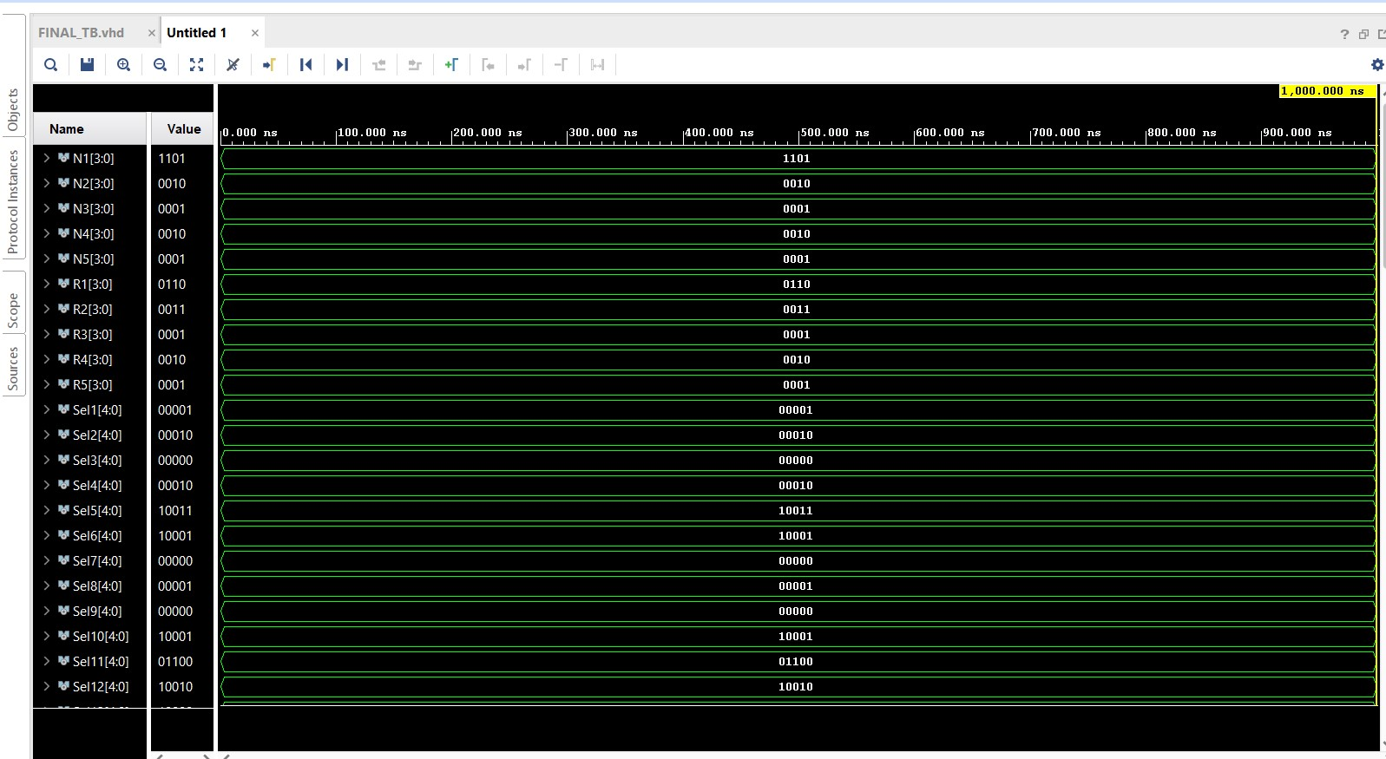

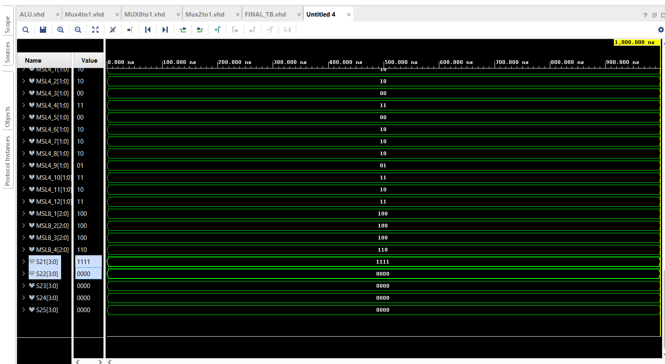

**For DFG-3**

**For DFG-4**

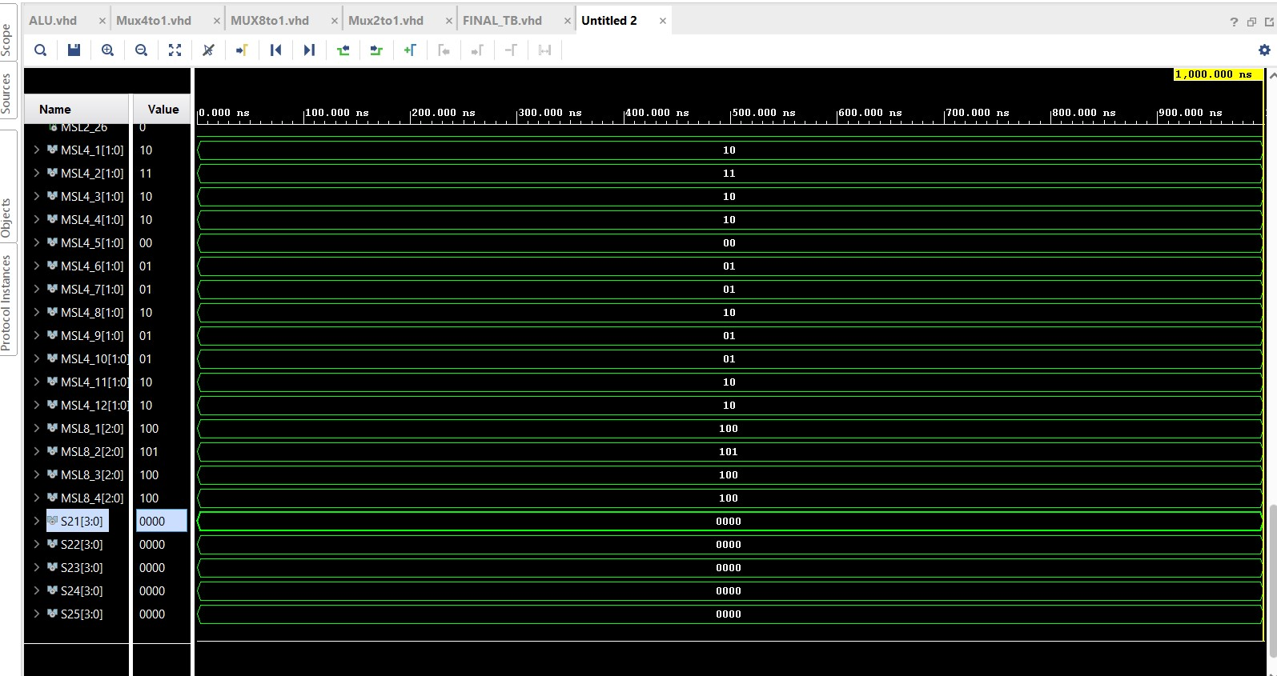

## 

## Table/Calculations

Dataflow1

|  |  |  |  |  |  |  |  |  |
| --- | --- | --- | --- | --- | --- | --- | --- | --- |
| CU# | Input 1 | Input 2 | 1 | 2 | Operation | Calculated  O/p | Simulated O/p | Match |
| CU 1 | N1 | R1 | 1001 | 0110 | ADD | 1111 | 1111 | Yes |
| CU 2 | N2 | R2 | 0100 | 0011 | MULTIPLY | 1100 | 1100 | Yes |
| CU 3 | N3 | R3 | 0010 | 0111 | ADD | 1001 | 1001 | Yes |
| CU 4 | N4 | R4 | 1111 | 1101 | SUB | 0010 | 0010 | Yes |
| CU 5 | N5 | R5 | 0001 | 0001 | MULTIPLY | 0001 | 0001 | Yes |
| CU 6 | N6 | R6 | 1111 | 1001 | SUB | 0010 | 0010 | Yes |
| CU 7 | N7 | R7 | 1001 | 0001 | ADD | 1010 | 1010 | Yes |
| CU 8 | N8 | R8 | 1100 | 0010 | SUB | 1010 | 1010 | Yes |
| CU 9 | N9 | R9 | 1100 | 0001 | PASS GATE 2 | 0001 | 0001 | Yes |
| CU 10 | N10 | R10 | 0001 | 0001 | NOOP | 0000 | 0000 | Yes |
| CU 11 | N11 | R11 | 0010 | 1010 | OR | 1110 | 1110 | Yes |
| CU 12 | N12 | R12 | 1010 | 1010 | AND | 1010 | 1010 | Yes |
| CU 13 | N13 | R13 | 0110 | 0001 | NAND | 0111 | 0111 | Yes |
| CU 14 | N14 | R14 | 1010 | 0001 | NOOP | 0000 | 0000 | Yes |
| CU 15 | N15 | R15 | 0001 | 0000 | NOOP | 0000 | 0000 | Yes |
| CU 16 | N16 | R16 | 1110 | 1010 | XOR | 0100 | 0100 | Yes |
| CU 17 | N17 | R17 | 1010 | 0111 | NOR | 0000 | 0000 | Yes |
| CU 18 | N18 | R18 | 1010 | 0000 | NOOP | 0000 | 0000 | Yes |
| CU 19 | N19 | R19 | 0111 | 0000 | NOOP | 0000 | 0000 | Yes |
| CU 20 | N20 | R20 | 0000 | 0000 | NOOP | 0000 | 0000 | Yes |
| CU 21 | N21 | R21 | 0100 | 0000 | PASS GATE 1 | 0100 | 0100 | Yes |
| CU 22 | N22 | R22 | 0100 | 0000 | PASS GATE 2 | 0000 | 0000 | Yes |
| CU 23 | N23 | R23 | 0000 | 0000 | NOOP | 0000 | 0000 | Yes |
| CU 24 | N24 | R24 | 0000 | 0000 | NOOP | 0000 | 0000 | Yes |
| CU 25 | N25 | R25 | 0000 | 0000 | NOOP | 0000 | 0000 | Yes |

Dataflow 2

|  |  |  |  |  |  |  |  |  |
| --- | --- | --- | --- | --- | --- | --- | --- | --- |
| CU# | Input 1 | Input 2 | 1 | 2 | Operation | Calculated  O/p | Simulated O/p | Match |
| CU 1 | N1 | R1 | 1101 | 0110 | SUB | 0111 | 0111 | Yes |
| CU 2 | N2 | R2 | 0010 | 0011 | MULTIPLY | 0110 | 0110 | Yes |
| CU 3 | N3 | R3 | 0001 | 0001 | NOOP | 0000 | 0000 | Yes |
| CU 4 | N4 | R4 | 0001 | 0001 | ADD | 0010 | 0010 | Yes |
| CU 5 | N5 | R5 | 0010 | 0010 | MULTIPLY | 0100 | 0100 | Yes |
| CU 6 | N6 | R6 | 0111 | 0110 | PASS GATE 1 | 0111 | 0111 | Yes |
| CU 7 | N7 | R7 | 0111 | 0010 | ADD | 1001 | 1001 | Yes |
| CU 8 | N8 | R8 | 0111 | 0100 | SUB | 0011 | 0011 | Yes |
| CU 9 | N9 | R9 | 0110 | 0100 | ADD | 1010 | 1010 | Yes |
| CU 10 | N10 | R10 | 0010 | 0000 | PASS GATE 1 | 0010 | 0010 | Yes |
| CU 11 | N11 | R11 | 0111 | 1010 | ROR | 1101 | 1101 | Yes |
| CU 12 | N12 | R12 | 1001 | 0011 | PASS GATE 2 | 0011 | 0011 | Yes |
| CU 13 | N13 | R13 | 1001 | 0010 | LSL | 0100 | 0100 | Yes |
| CU 14 | N14 | R14 | 0011 | 1010 | NOOP | 0000 | 0000 | Yes |
| CU 15 | N15 | R15 | 1010 | 0010 | NOOP | 0000 | 0000 | Yes |
| CU 16 | N16 | R16 | 1101 | 0100 | GREATER THAN | 1111 | 1111 | Yes |
| CU 17 | N17 | R17 | 1101 | 0011 | EQUAL TO | 0000 | 0000 | Yes |
| CU 18 | N18 | R18 | 0011 | 0000 | NOOP | 0000 | 0000 | Yes |
| CU 19 | N19 | R19 | 0100 | 0000 | NOOP | 0000 | 0000 | Yes |
| CU 20 | N20 | R20 | 0000 | 0000 | NOOP | 0000 | 0000 | Yes |
| CU 21 | N21 | R21 | 1111 | 1111 | PASS GATE 1 | 1111 | 1111 | Yes |
| CU 22 | N22 | R22 | 1111 | 0000 | PASS GATE 2 | 0000 | 0000 | Yes |
| CU 23 | N23 | R23 | 0000 | 0000 | NOOP | 0000 | 0000 | Yes |
| CU 24 | N24 | R24 | 0000 | 0000 | NOOP | 0000 | 0000 | Yes |
| CU 25 | N25 | R25 | 0000 | 0000 | NOOP | 0000 | 0000 | Yes |

Dataflow 3

|  |  |  |  |  |  |  |  |  |
| --- | --- | --- | --- | --- | --- | --- | --- | --- |
| CU# | Input 1 | Input 2 | 1 | 2 | Operation | Calculated  O/p | Simulated O/p | Match |
| CU 1 | N1 | R1 | 1000 | 0101 | MULT | 1101 | 1101 | Yes |
| CU 2 | N2 | R2 | 1110 | 1000 | SUB | 0110 | 0110 | Yes |
| CU 3 | N3 | R3 | 0001 | 0100 | MULT | 0100 | 0100 | Yes |
| CU 4 | N4 | R4 | 0011 | 0010 | MULT | 0110 | 0110 | Yes |
| CU 5 | N5 | R5 | 0001 | 0001 | NOOP | 0000 | 0000 | Yes |
| CU 6 | N6 | R6 | 1101 | 0110 | SUB | 0111 | 0111 | Yes |
| CU 7 | N7 | R7 | 0110 | 0100 | PASS GATE 2 | 0100 | 0100 | Yes |
| CU 8 | N8 | R8 | 0110 | 0110 | ADD | 1100 | 1100 | Yes |
| CU 9 | N9 | R9 | 0110 | 0110 | SUB | 0000 | 0000 | Yes |
| CU 10 | N10 | R10 | 0000 | 0000 | NOOP | 0000 | 0000 | Yes |
| CU 11 | N11 | R11 | 0111 | 0100 | NOR | 1000 | 1000 | Yes |
| CU 12 | N12 | R12 | 1100 | 0000 | NAND | 1111 | 1111 | Yes |
| CU 13 | N13 | R13 | 1100 | 0000 | NOOP | 0000 | 0000 | Yes |
| CU 14 | N14 | R14 | 1100 | 0000 | NOOP | 0000 | 0000 | Yes |
| CU 15 | N15 | R15 | 0000 | 0000 | NOOP | 0000 | 0000 | Yes |
| CU 16 | N16 | R16 | 1000 | 1000 | PASS GATE 1 | 1000 | 1000 | Yes |
| CU 17 | N17 | R17 | 1000 | 1111 | PASS GATE 2 | 1111 | 1111 | Yes |
| CU 18 | N18 | R18 | 1111 | 0000 | NOOP | 0000 | 0000 | Yes |
| CU 19 | N19 | R19 | 0000 | 0000 | NOOP | 0000 | 0000 | Yes |
| CU 20 | N20 | R20 | 0000 | 0000 | NOOP | 0000 | 0000 | Yes |
| CU 21 | N21 | R21 | 1000 | 1000 | PASS GATE 1 | 1000 | 1000 | Yes |
| CU 22 | N22 | R22 | 1000 | 1111 | PASS GATE 2 | 1111 | 1111 | Yes |
| CU 23 | N23 | R23 | 1111 | 0000 | NOOP | 0000 | 0000 | Yes |
| CU 24 | N24 | R24 | 0000 | 0000 | NOOP | 0000 | 0000 | Yes |
| CU 25 | N25 | R25 | 0000 | 0000 | NOOP | 0000 | 0000 | Yes |

Dataflow 4

|  |  |  |  |  |  |  |  |  |
| --- | --- | --- | --- | --- | --- | --- | --- | --- |
| CU# | Input 1 | Input 2 | 1 | 2 | Operation | Calculated  O/p | Simulated O/p | Match |
| CU 1 | N1 | R1 | 0100 | 0010 | MULT | 1000 | 1000 | Yes |
| CU 2 | N2 | R2 | 0011 | 0100 | ADD | 0111 | 0111 | Yes |
| CU 3 | N3 | R3 | 1111 | 1010 | SUB | 0101 | 0101 | Yes |
| CU 4 | N4 | R4 | 0010 | 0010 | MULT | 0100 | 0100 | Yes |
| CU 5 | N5 | R5 | 0001 | 0001 | NOOP | 0000 | 0000 | Yes |
| CU 6 | N6 | R6 | 1000 | 0101 | ADD | 1101 | 1101 | Yes |
| CU 7 | N7 | R7 | 0111 | 0100 | ADD | 1011 | 1011 | Yes |
| CU 8 | N8 | R8 | 0101 | 0100 | SUB | 0001 | 0001 | Yes |
| CU 9 | N9 | R9 | 0111 | 0100 | NOOP | 0000 | 0000 | Yes |
| CU 10 | N10 | R10 | 0000 | 0000 | NOOP | 0000 | 0000 | Yes |
| CU 11 | N11 | R11 | 1101 | 1011 | LSR | 0000 | 0000 | Yes |
| CU 12 | N12 | R12 | 1101 | 0001 | R0L | 1011 | 1011 | Yes |
| CU 13 | N13 | R13 | 1011 | 0001 | ASL | 0110 | 0110 | Yes |
| CU 14 | N14 | R14 | 0001 | 0000 | NOOP | 0000 | 0000 | Yes |
| CU 15 | N15 | R15 | 0000 | 0000 | NOOP | 0000 | 0000 | Yes |
| CU 16 | N16 | R16 | 0000 | 1011 | XOR | 1011 | 1011 | Yes |
| CU 17 | N17 | R17 | 1011 | 0110 | XNOR | 0010 | 0010 | Yes |
| CU 18 | N18 | R18 | 1011 | 0000 | NOOP | 0000 | 0000 | Yes |
| CU 19 | N19 | R19 | 0110 | 0000 | NOOP | 0000 | 0000 | Yes |
| CU 20 | N20 | R20 | 0000 | 0000 | NOOP | 0000 | 0000 | Yes |
| CU 21 | N21 | R21 | 1011 | 0010 | LESS THAN | 0000 | 0000 | Yes |
| CU 22 | N22 | R22 | 1011 | 0010 | NOOP | 0000 | 0000 | Yes |
| CU 23 | N23 | R23 | 0010 | 0000 | NOOP | 0000 | 0000 | Yes |
| CU 24 | N24 | R24 | 0000 | 0000 | NOOP | 0000 | 0000 | Yes |
| CU 25 | N25 | R25 | 0000 | 0000 | NOOP | 0000 | 0000 | Yes |

